LARAVEL DOCUMITATION
Laravel is an open-source PHP framework, which is robust and easy to understand. It follows a model-view-controller design pattern. Laravel reuses the existing components of different frameworks which helps in creating a web application. The web application thus designed is more structured and pragmatic.
Laravel offers a rich set of functionalities which incorporates the basic features of PHP frameworks like CodeIgniter, Yii and other programming languages like Ruby on Rails. Laravel has a very rich set of features which will boost the speed of web development.

Advantages of Laravel

- The web application becomes more scalable, owing to the Laravel framework.
- Considerable time is saved in designing the web application, since Laravel reuses the components from other framework in developing web application.
- It includes namespaces and interfaces, thus helps to organize and manage resources.

Composer
Composer is a tool which includes all the dependencies and libraries. It allows a user to create a project with respect to the mentioned framework (for example, those used in Laravel installation). Third party libraries can be installed easily with help of composer.
All the dependencies are noted in composer.json file which is placed in the source folder.

Features of Laravel
Laravel offers the following key features which makes it an ideal choice for designing web applications −
Modularity
Laravel provides 20 built in libraries and modules which helps in enhancement of the application. Every module is integrated with Composer dependency manager which eases updates.
Testability
Laravel includes features and helpers which helps in testing through various test cases. This feature helps in maintaining the code as per the requirements.
Routing
Laravel provides a flexible approach to the user to define routes in the web application. Routing helps to scale the application in a better way and increases its performance.
Configuration Management
A web application designed in Laravel will be running on different environments, which means that there will be a constant change in its configuration. Laravel provides a consistent approach to handle the configuration in an efficient way.
Query Builder and ORM
Laravel incorporates a query builder which helps in querying databases using various simple chain methods. It provides ORM (Object Relational Mapper) and ActiveRecord implementation called Eloquent.
Schema Builder
Schema Builder maintains the database definitions and schema in PHP code. It also maintains a track of changes with respect to database migrations.
Template Engine
Laravel uses the Blade Template engine, a lightweight template language used to design hierarchical blocks and layouts with predefined blocks that include dynamic content.
E-mail
Laravel includes a mail class which helps in sending mail with rich content and attachments from the web application.
Authentication
User authentication is a common feature in web applications. Laravel eases designing authentication as it includes features such as register, forgot password and send password reminders.
Redis
Laravel uses Redis to connect to an existing session and general-purpose cache. Redis interacts with session directly.
Queues
Laravel includes queue services like emailing large number of users or a specified Cron job. These queues help in completing tasks in an easier manner without waiting for the previous task to be completed.
Event and Command Bus
Laravel 5.1 includes Command Bus which helps in executing commands and dispatch events in a simple way. The commands in Laravel act as per the application’s lifecycle.

MVC MODEL VIEW CONTROLLER
Explained by jainik sir model holds our database view holds the UI part
And controller placed the Logics in another words we can say Api integration
OUR WORK
MODEL AND CONTROLLER ITS OUR PART
API INTIGRATION -DEFIND ONE BACKEND AND USE TWICE TO SEND THE DIFFERENT
USER INTER FACE AS BEING CONVERTED IN API
Why MVC ?
It is mainly used to separate Application code into user interfaces, data, and controlling logic. It can benefit the developer to easily maintain the code which can help to make a development process much smooth

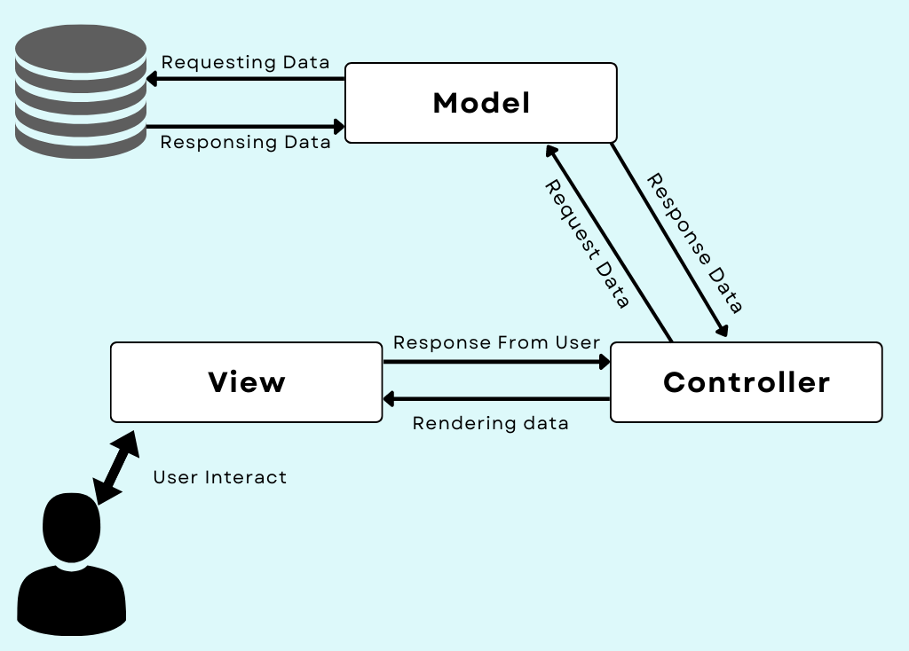

Model:
This component of the MVC framework handles data used in your application. It helps to retrieve the data from the database and then perform some operation that your application is supposed to perform then it stores that data back in the database.
In simple words, we can say that Model is responsible for managing data that is passed between the database and the User Interface (View).
View:
This component is User Interface, which defines the template which is sent as a response to the browser. This View components contain the part of code which helps to display data to the User Interface on the user’s browser. For example, we can say the buttons, textbox, dropdown menu, and many more such widgets on the browser screen are the part of View Component.
Controller:
This controller component helps to interact with the model component to fetch data from the database and then pass that data to the view component to get the desired output on the user’s browser screen. Same way, when the user enters some data the controller fetches that data and then performs some operation or just inserts that data into the database with the use of the model components.
MVC DEEP OVERVIEW
MODEL :
Used to apply for the business or complex logic and which fields wants from the database
VIEW :
Used to store browser UI
CONTROLLER :
Controllee will handle intraction between database and UI OR VIEW

LARVEL VERSION COMHPERSION

- LARAVEL VERSION 6X AND 7X

- BOTH ARE USING PHP VERSION 7.2

he primary difference between Laravel versions 6 and 7 is theIntroduction of "Laravel Sanctum" in version 7, a dedicated authentication system for API applications, alongside various improvements in routing speed, Blade component support, CORS management, and enhanced Eloquent features, making Laravel 7 significantly more focused on API development compared to version 6; Additionally, version 7 requires a newer Symfony version and may have changes in date serialization and other minor features.
Key points about the differences:
- Sanctum:
Laravel 7 introduced Sanctum, a dedicated API authentication system, while version 6 lacks this feature.
- Blade Components:
While Blade components were available in version 6, Laravel 7 significantly enhanced their functionality with new features and syntax improvements.
- CORS Support:
Version 7 includes built-in CORS (Cross-Origin Resource Sharing) support, which was not as readily available in version 6.
- Improved Routing:
Laravel 7 boasts performance enhancements in routing compared to version 6.
- Dependency Updates:
Upgrading from version 6 to 7 typically requires updating to a newer Symfony version.

- LARAVEL VERSION 7X AND 8X

The primary difference between Laravel 7 and 8 is the introduction of "Laravel Jetstream" in version 8, a comprehensive authentication scaffolding system that offers features like email verification, two-factor authentication, and profile management, whereas Laravel 7 primarily focused on the Sanctum package for API authentication and lacked such robust user interface features for authentication flows; additionally, Laravel 8 includes improvements to model factories, migration squashing, job batching, better rate limiting, and enhanced Blade component capabilities compared to Laravel 7.
Key points about the differences:
- Authentication system:
Laravel 7 mainly uses Sanctum for API authentication, while Laravel 8 introduces Jetstream, a full-fledged authentication system with a richer user interface and features.
- UI improvements:
Laravel 8 leverages Tailwind CSS in Jetstream, providing a more modern and customizable look compared to Laravel 7.
- Model management:
Laravel 8 offers enhanced model factories and migration squashing capabilities for better database management.
- Job handling:
Job batching is introduced in Laravel 8, allowing for better management of queued jobs.
- Rate Limiting:
Laravel 8 has improved rate limiting features compared to Laravel

- LARAVEL VERSION 8X AND 9X

The primary difference between Laravel version 8 and 9 is that Laravel 9 incorporates several new features and improvements built upon the foundation of Laravel 8, including a mandatory upgrade to PHP 8.0, the adoption of Symfony Mailer instead of SwiftMailer for email sending, integration with Flysystem 3.x for file system operations, enhanced Eloquent accessors and mutators, and improved route listing output; essentially, Laravel 9 offers a more modern and streamlined development experience with updated dependencies and functionalities compared to Laravel 8.
Key points about the differences:
- PHP version requirement:
Laravel 9 requires a minimum PHP version of 8.0, while Laravel 8 can work with slightly older PHP versions.
- Mailer integration:
Laravel 9 uses Symfony Mailer for sending emails, whereas Laravel 8 utilizes the older SwiftMailer library.
- Flysystem version:
Laravel 9 integrates with Flysystem 3.x, providing updated file system management capabilities.
- Eloquent improvements:
Laravel 9 features enhanced Eloquent accessors and mutators for more refined data manipulation.
- Other updates:
Laravel 9 includes various bug fixes, better route listing output, and support for new features like implicit route bindings via Enum

- LARAVEL VERSION 9X AND 10X

The primary difference between Laravel version 9 and 10 is that Laravel 10 introduces several new features and improvements, including better support for type hinting, a dedicated feature flag package called "Laravel Pennant", enhanced testing capabilities, and a requirement for PHP version 8.1 or higher, while Laravel 9 supports older PHP versions and has a slightly smaller feature set.
Key points about Laravel 10 compared to Laravel 9:
- PHP version requirement:
Laravel 10 mandates using PHP 8.1 or above, whereas Laravel 9 can work with older PHP versions like 8.0.
- Laravel Pennant:
Laravel 10 includes a built-in feature flag package called "Laravel Pennant" for managing application features.
- Improved type hinting:
Laravel 10 utilizes native PHP type hints throughout the application skeleton, providing better code clarity.
- Testing enhancements:
Laravel 10 offers new testing features like the ability to easily identify slow-running tests.

While Laravel versions 10, 11, and 12 all share a core framework, the key difference lies in the newer features and improvements introduced with each subsequent release,
LARAVEL DAY 2

- LARAVEL VERSION 10X,11X AND 12X

including enhancements like per-second rate limiting in Laravel 11, streamlined application structure, and further integration with modern frontend frameworks like React and Vue in Laravel 12, alongside updated dependencies and potential new starter kits for authentication solutions like WorkOS AuthKit.
Key points about each version:
- Laravel 10:
Introduced "Laravel Pennant" for feature flags management, improved test identification for slow-running tests, and adopted invokable validation rules by default.
- Laravel 11:
Added per-second rate limiting, Resend mail transport, Prompt validator integration, improved queue testing capabilities, and a more minimal application skeleton.
- Laravel 12:
Continued improvements from Laravel 11, with a focus on updated starter kits for React, Vue, and Livewire, potentially including options to use WorkOS AuthKit for user authentication with social login and SSO feature

LARAVEL 10th VERSION R&D AND IMPLMETION

Creating a Laravel Project

Before creating your first Laravel project, make sure that your local machine has PHP and Composer installed. If you are developing on macOS, PHP and Composer can be installed in minutes via Laravel Herd. In addition, we recommend installing Node and NPM.

After you have installed PHP and Composer, you may create a new Laravel project via Composer's create-project command:

composer create-project "laravel/laravel:^10.0" example-app

Or, you may create new Laravel projects by globally installing the Laravel installer via Composer:

composer global require laravel/installer

laravel new example-app

Once the project has been created, start Laravel's local development server using
Laravel Artisan's serve command:

cd example-app
php artisan serve

Directory Structure
- Introduction
- The Root Directory
  - The app Directory
  - The bootstrap Directory
  - The config Directory
  - The database Directory
  - The public Directory
  - The resources Directory
  - The routes Directory
  - The storage Directory
  - The tests Directory
  - The vendor Directory
- The App Directory
  - The Broadcasting Directory
  - The Console Directory
  - The Events Directory
  - The Exceptions Directory
  - The Http Directory
  - The Jobs Directory
  - The Listeners Directory
  - The Mail Directory
  - The Models Directory
  - The Notifications Directory
  - The Policies Directory
  - The Providers Directory
  - The Rules Directory

The App Directory
The app directory contains the core code of your application. We'll explore this directory in more detail soon; however, almost all of the classes in your application will be in this directory.
The Bootstrap Directory
The bootstrap directory contains the app.php file which bootstraps the framework. This directory also houses a cache directory which contains framework generated files for performance optimization such as the route and services cache files. You should not typically need to modify any files within this directory.
The Config Directory
The config directory, as the name implies, contains all of your application's configuration files. It's a great idea to read through all of these files and familiarize yourself with all of the options available to you.
The Database Directory
The database directory contains your database migrations, model factories, and seeds. If you wish, you may also use this directory to hold an SQLite database.
The Public Directory
The public directory contains the index.php file, which is the entry point for all requests entering your application and configures autoloading. This directory also houses your assets such as images, JavaScript, and CSS.

